Student Name: Xianglong Lin Student Number: 45791439 Team Name: H2OMG
Week: _10_
Title: Enhancing User Usability through Think-Aloud Evaluation
Description:
In the 10th week, my focus in the studio was user evaluation, which was using think-aloud
to evaluate the usability and user experience of the current high-fidelity prototype of the water conservation system. This protocol emphasised the user to express ideas and feelings about using and interacting with different functions during the operation of the water system. During the evaluation process, a representative from another team was sent to my team. The user's tasks such as setting water use goals and interpreting water usage analysis were observed and I asked the representative about the experience using them, such as “How useful is the water usage report?” and “Do you prefer daily or weekly goal notifications?” These questions helped me better understand user needs and preferences. This test provided valuable insights into the user experience of the prototype, such as the difficulties the user encountered when interpreting data and the need for more intuitive navigation buttons.
Visual Evidence:
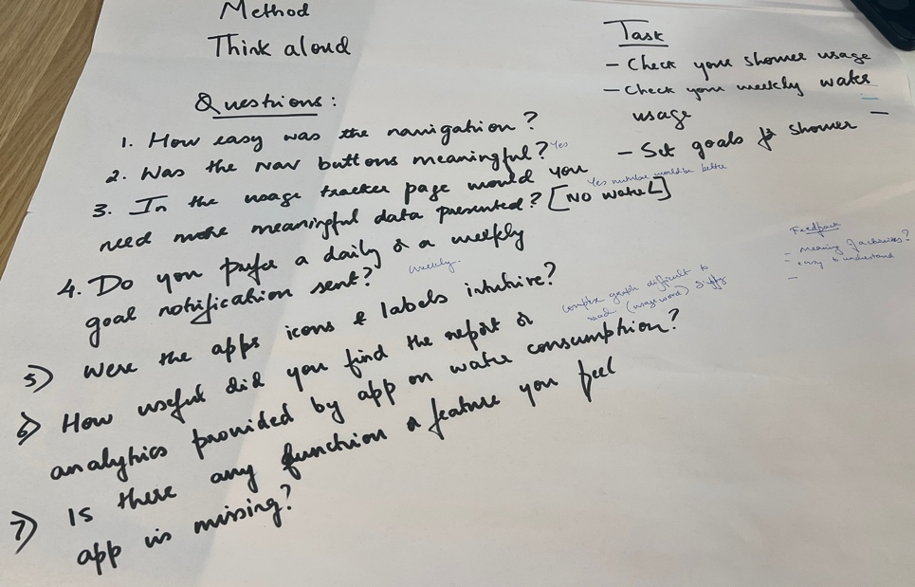
Statement on Learning:
This week's studio activity highlights the critical role of direct interaction with users in order to collect real usability feedback. Compared to last week's user enactment activity, think-aloud enabled me to gain a deeper understanding of specific aspects and details of user interaction, such as the intuitive nature of navigation and the clarity of information presentation. For example, users had difficulty understanding certain icons and analysis charts, which had made me realise the importance of clearer labels and more concise presentation methods, both in prototype design and front-end interface coding. This feedback is different from the activity simulation of the controlled scenario last week, which was more user-oriented in a specific shower room setting.
The feedback from the think-aloud prompted significant adjustments to the next design iteration. Specifically, the user interface is needed to be enhanced, clearer navigation buttons should be used to make the analysis data more easily understood visually, and perhaps the complex information (e.g. water flow amount) should be simplified into a more intuitive presentation form. Unlike last week's user enactment, this week's activity leveraged real user experience to improve basic usability. Next, a portion of the front-end interface will be redesigned to make it more user-friendly and engaging, ensuring that users can interact with actionable information in a visually appealing way.

